

ANALYSIS FOR NPTEL ATTENDING COURSES

Semester | Present | Gold | Silver | Elite | Successful | Topper
Jan-June 2015 | 1 | 0 | NA | 1 | 0 | 0
Jul-Dec 2016 | 16 | 1 | NA | 8 | 6 | 2
Jan-June 2017 | 54 | 2 | NA | 13 | 20 | 3
Jul-Dec 2017 | 27 | 0 | NA | 10 | 16 | 2
Jan-Apr 2018 | 313 | 2 | NA | 125 | 151 | 11
Jul-Oct 2018 | 1334 | 15 | NA | 713 | 485 | 31
Jan-Apr 2019 | 483 | 20 | 141 | 62 | 200 | 15
July-Dec 2019 | 907 | 2 | 76 | 267 | 255 | 11

NPTEL SUCCESS ANALYSIS
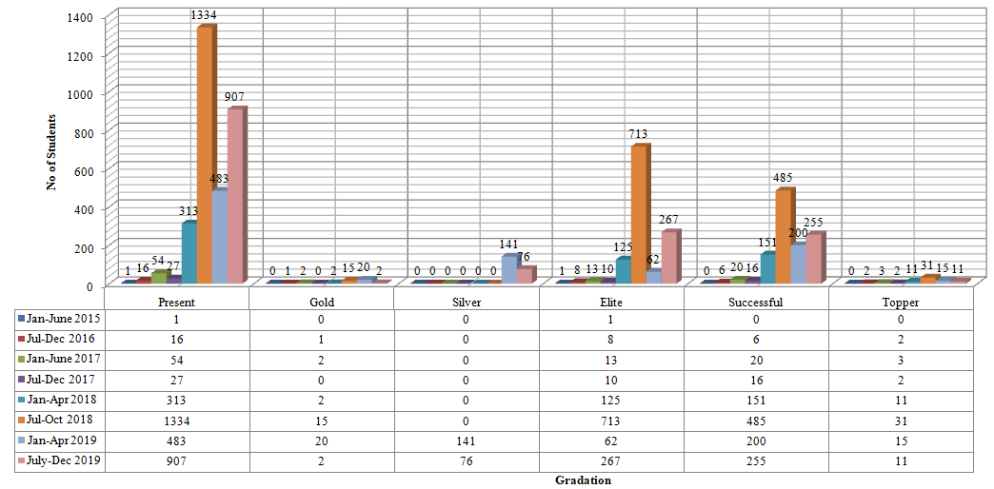

MOOCs ADOPTED BY STUDENTS
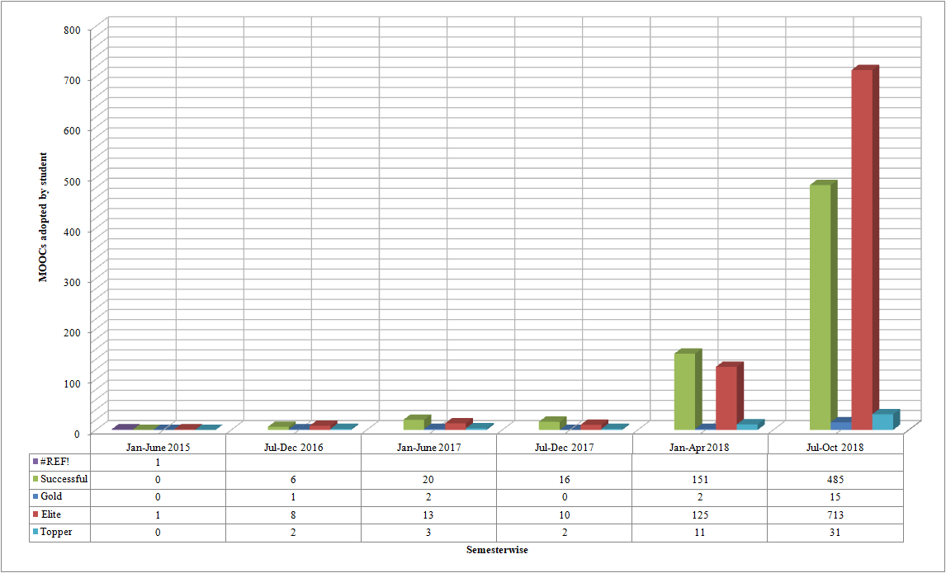

DEPARTMENT WISE ANALYSIS OF NPTEL DATA
 | July-Oct'17 |  | Jan-April'18 |  | July-Oct'18 |  | Jan-April'19 |  | July-Oct'19
 | Appeared | Qualified | Appeared | Qualified | Appeared | Qualified | Appeared | Qualified | Appeared | Qualified
IT | 2 | 2 | 50 | 44 | 68 | 62 | 20 | 15 |  | 17
CSE | 5 | 5 | 120 | 112 | 197 | 185 | 125 | 118 |  | 28
ECE | 5 | 4 | 40 | 35 | 262 | 237 | 63 | 59 |  | 48
AEIE | 0 | 0 | 16 | 16 | 42 | 38 | 10 | 8 |  | 4
EE | 1 | 1 | 18 | 14 | 170 | 137 | 42 | 38 |  | 29
ME | 2 | 2 | 12 | 6 | 148 | 135 | 57 | 35 |  | 31
CE | 0 | 0 | 23 | 22 | 155 | 132 | 18 | 11 |  | 10

DEPARTMENT WISE ANALYSIS OF NPTEL DATA

