EFFORTS OF THE INSTITUTION IN CELEBRATING /ORGANIZING NATIONAL AND INTERNATIONAL COMMEMORATIVE DAYS, EVENTS AND FESTIVALS DURING LAST ONE YEAR

The institute has a rich history of commemorating national and international holidays, occasions, and festivals. In addition, the institute's buildings bear the names of notable individuals and visionaries, including Sister Nivedita Girls Hostel, Chittaranjan Boys Hostel, Satyen Bose Boys Hostel, and Vidyasagar Bhawan. Vivek Udyan, Rabindra Udyan, Bidhan Udyan, etc. are some of the names of the gardens. Some of them are attached below as supporting documents.

Annual report of the celebrations and commemorative events for the last one year

* Name of the event: **Celebration of Republic Day**
* Date: 26th January 2022.
* Venue: Institute Campus



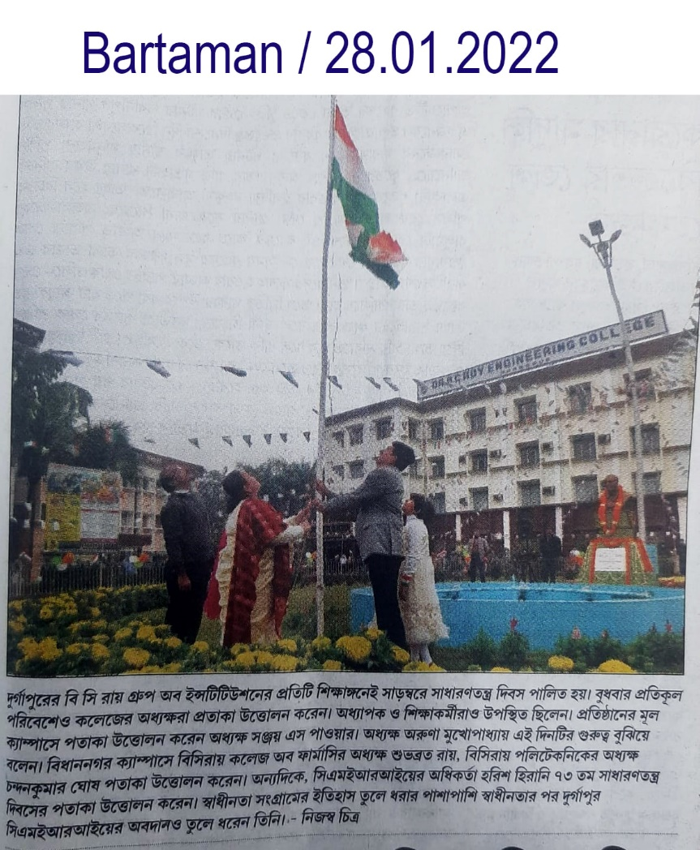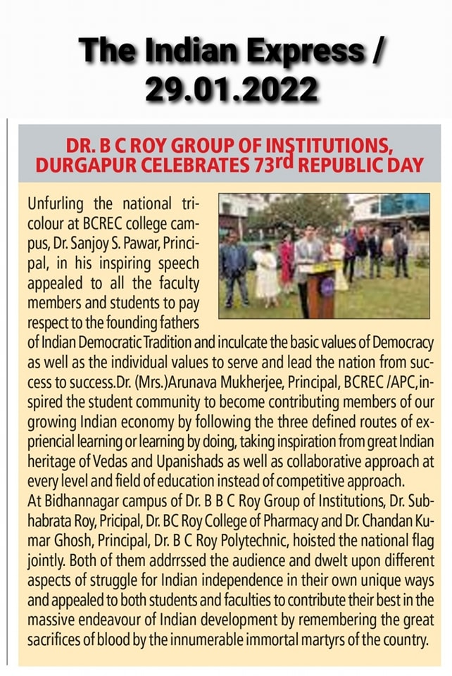

2. Name of the event: **Celebration of Independence Day**

Date: 15th August 2022

Venue: Institute Campus

