Section: 7.1.1
Measures initiated by the Institution for the promotion of gender equity

Our Institute performs gender sensitivity by the following measures
1. Safety and security
2. Counselling
3. Common Rooms
4. Any other relevant information

Campus Rules
Appointment of Lady Security Guards:
Name of the Document:
MoU between BCREC and the Security Agency (Sample Page) Academic Year: 2021-22 (01st July 2021 – 30th June 2022)
Security Camera

Committees for Grievance Redressal (GR)
Name of the Document: Grievance Redressal (GR) committee and minutes of meeting Academic Year: 2021-2022

Vigilance awareness week
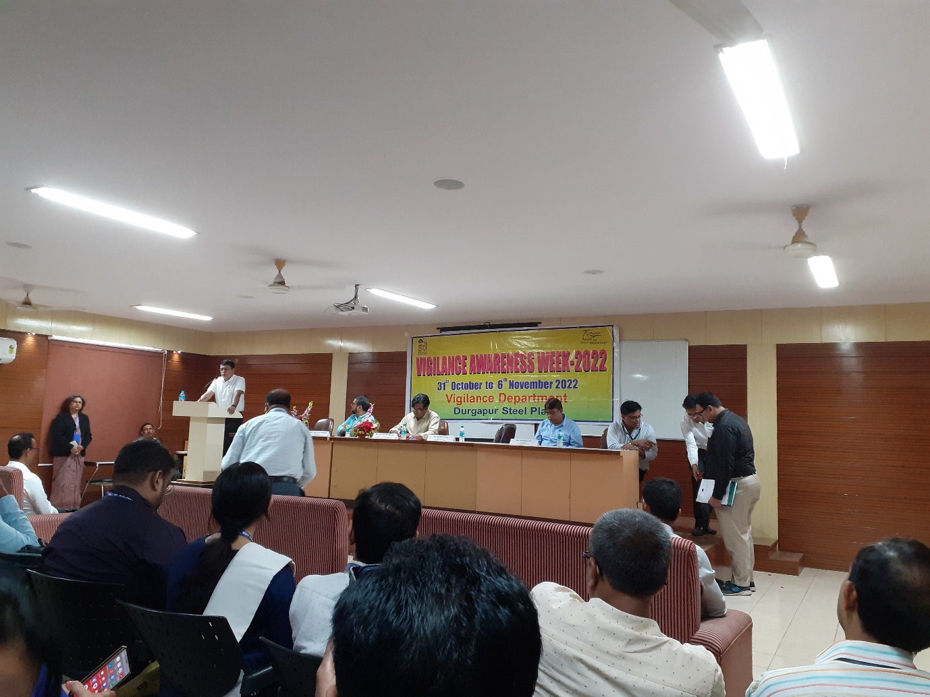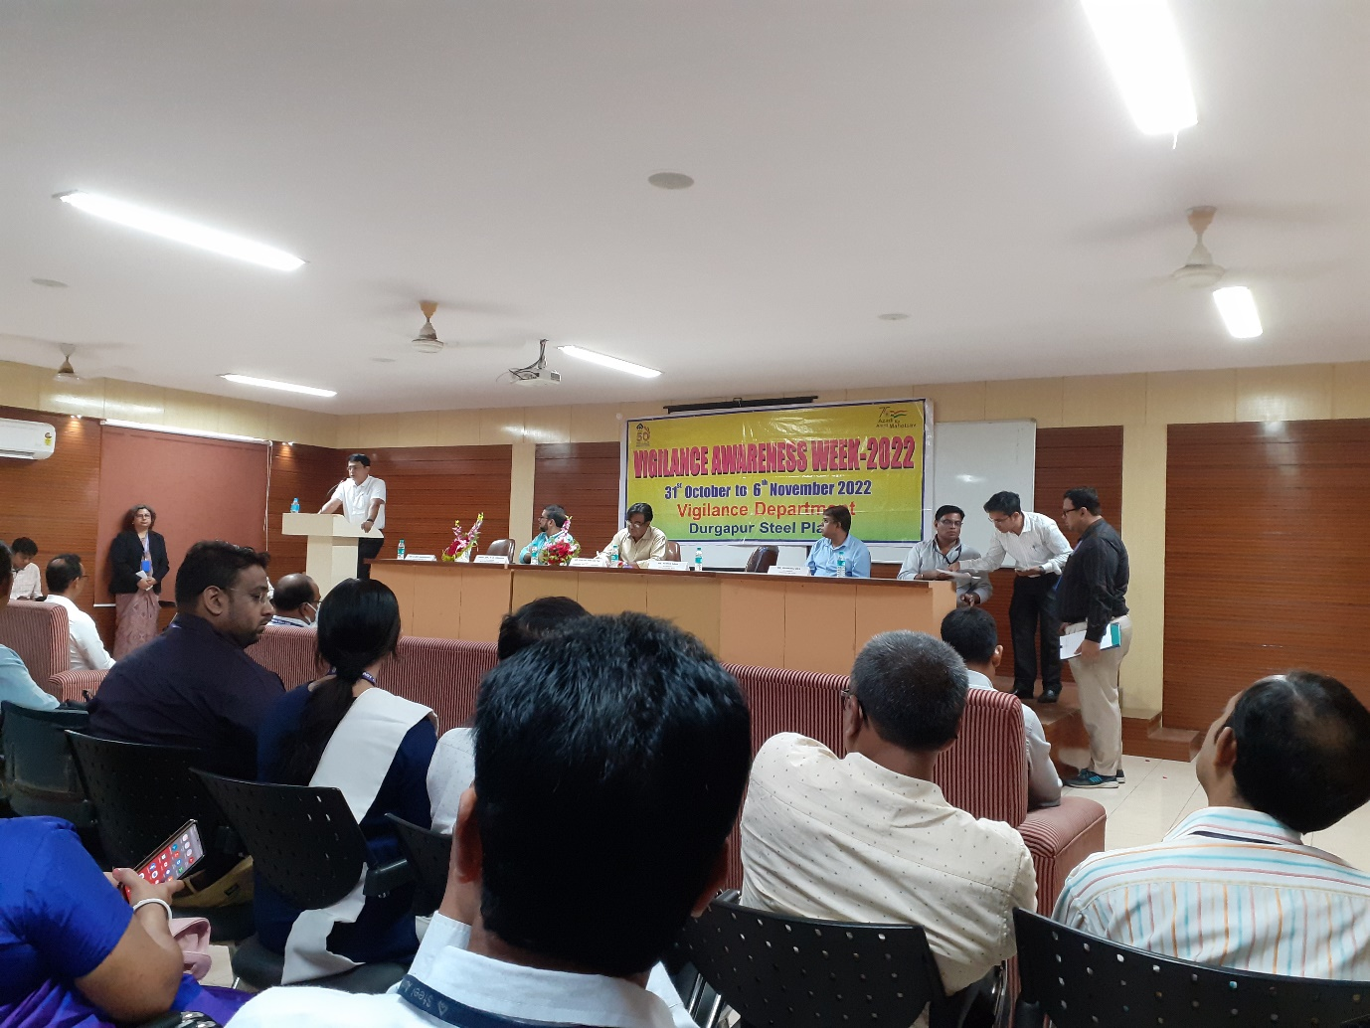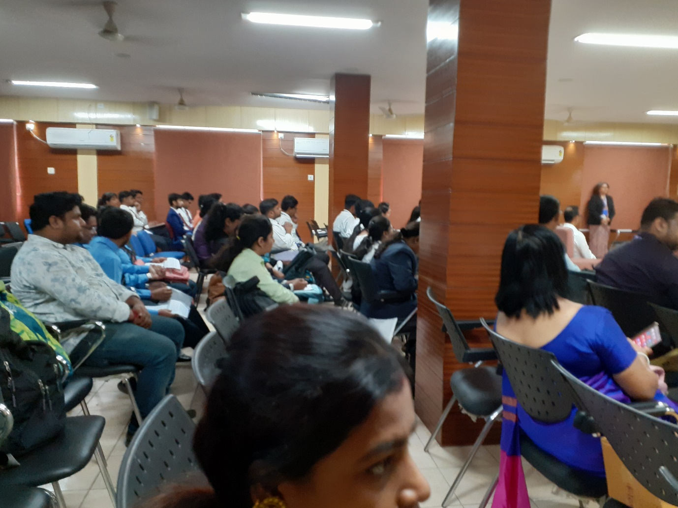
Name of the Event: Vigilance awareness week Academic Year: 2021-22
Duration:

Karate (included in other relevant documents)

Name of the Document: Karate of the girl students’ Academic Year: 2021-22

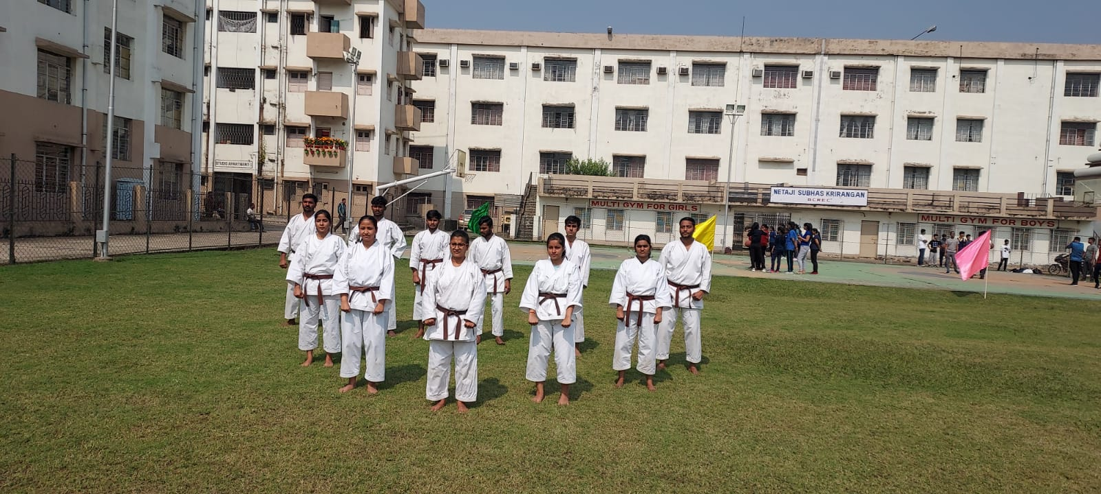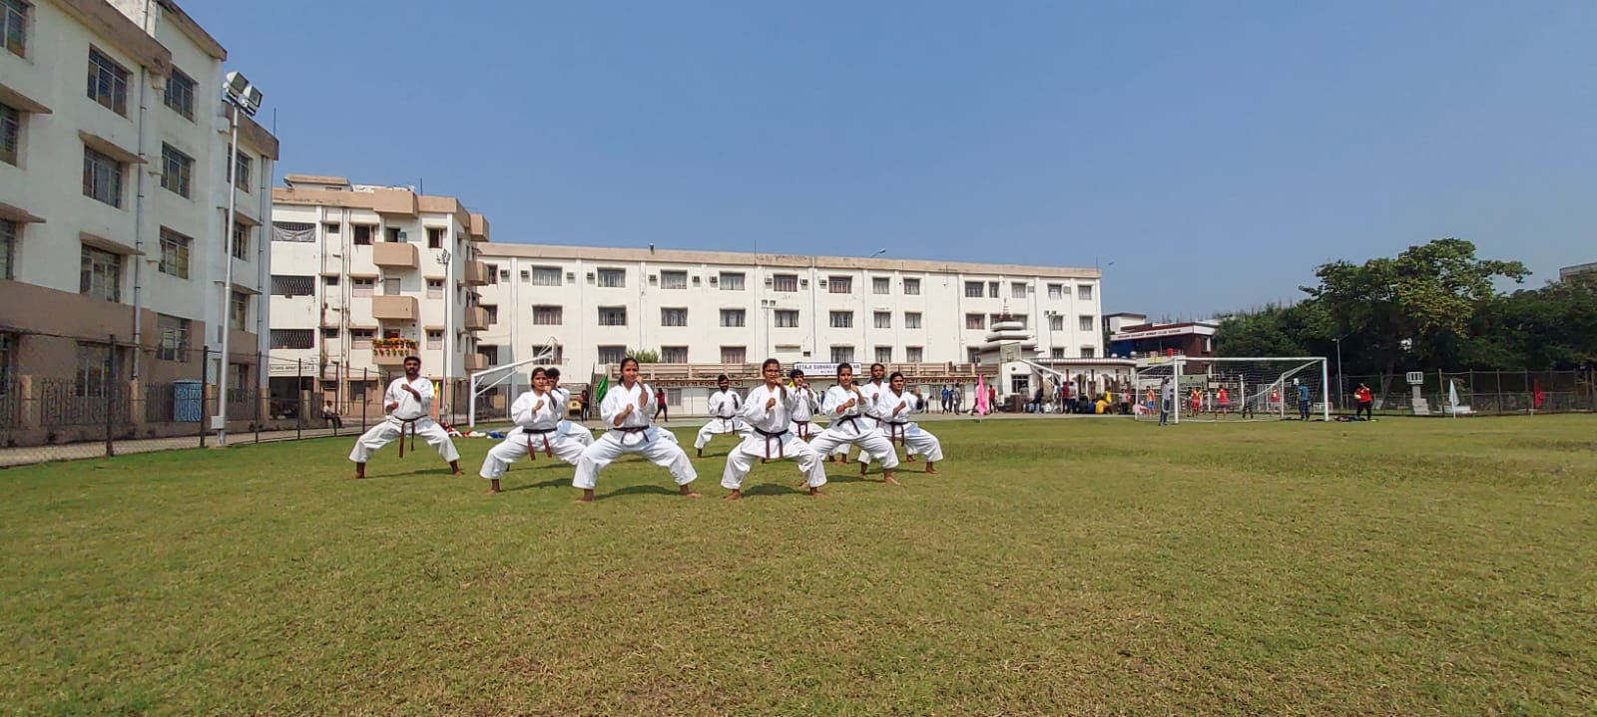
Counselling

Name of the Document: Appointment letter of the counsellor Academic Year

3. Common Rooms

Separate gymnasium

