**Section: 7.1.1**

**Measures initiated by the Institution for the promotion of gender equity**

Our Institute performs gender sensitivity by the following measures

1. Safety and security

2. Counselling

3. Common Rooms

4. Any other relevant information

**Campus Rules**

Appointment of Lady Security Guards:

**Name of the Document:**

MoU between BCREC and the Security Agency (Sample Page) Academic Year: 2020-21 (***01st July 2020 – 30th June 2021***)

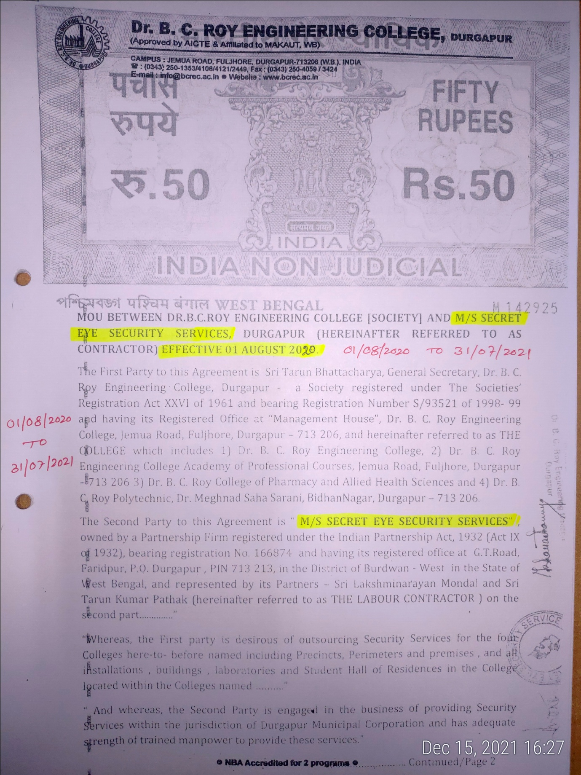

**Security Camera**

**Committees for Grievance Redressal (GR)**

Name of the Document: Grievance Redressal (GR) committee and minutes of meeting Academic Year: 2020-2021

Vigilance awareness week

**Name of the Event:** Vigilance awareness week Academic Year: 2020-21

**Duration:**

Karate (included in other relevant documents)

**Name of the Document:** Karate of the girl students Academic Year: 2020-21

Counselling

Name of the Document: Appointment letter of the counsellor Academic Year

3. Common Rooms

Separate gymnasium